**Impact of Covid on bank credit repayment and payment system of India**

**1. Introduction**

Over the past couple of years, the GDP growth rate has been falling, 2018(6.8%), 2019(4.2%) and was expected to be 4.6% percent in 2020. However, due to the imposed lockdown recent conservative estimates place the growth rate to be 1.8% while extreme estimates suggest that the growth rate might be in negative territory (for the first time since 1979).

Due to extreme contagious nature of the COVID-19 virus, the Government of India has had to implement several restrictions to curb the outbreak. The brunt of the economic consequences of the restrictions has been faced majorly by the aviation, tourism and hospitality sector. Since the lockdown allows only the essential sectors to continue to function, the spending of disposable income is expected to reduce drastically. The impact of this would be seen in the volume and amount of the several of methods of payments such as UPI, NEFT, RTGS and so on.

This report presents the extent to which COVID-19 and the subsequent nationwide lockdown has impacted the financial transactions of the nation.

**2. India’s COVID-19 situation**

The first case of COVID-19 was reported in January end. While the number of cases remained low in the month of February, the number of cases started to rise in the month of March, which led the government to implement a nationwide lockdown in the country. The current mortality rate of COVID-19 in India stands at 2.82% while the recovery rate is at 47.97%. The number of new cases is constantly increasing as can be seen in the graphs below.

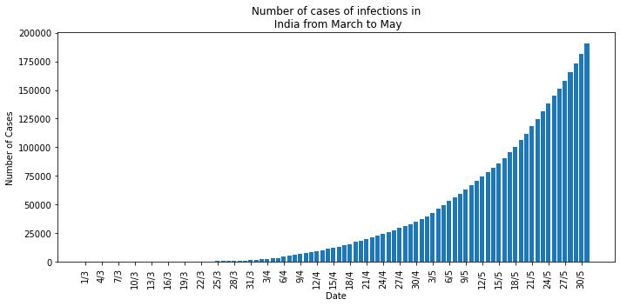

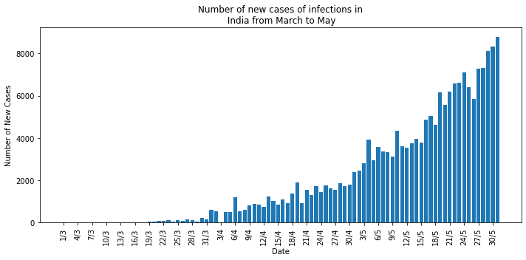

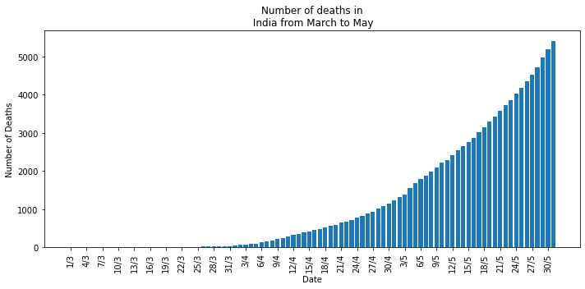

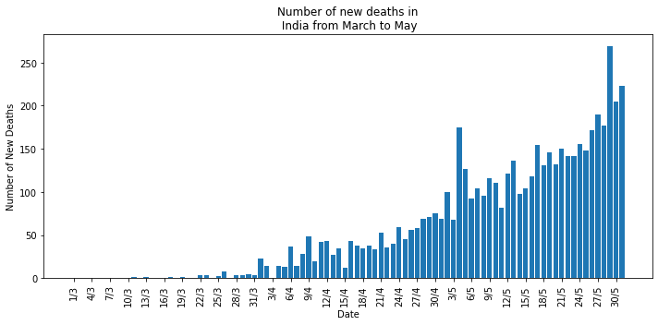

**3. Impact of COVID related lockdown on country’s payment systems**

**3.1. RTGS**

The Volume of transactions of RTGS has been varying from January 2019 until the month of February 2020, however, it fell by almost more than 10% in the month of March 2020. This drop may be attributed to the week-long nationwide lockdown as a precautionary measure against COVID-19 in the last week of the month of March.

A contrasting trend is observed in the amount of RTGS transactions. Since July 2019 there has been a downward trend in the amount of transactions for RTGS which could have been the result of the economic slowdown of India since the 2nd quarter of the current fiscal year (2019-20).





**3.2. NEFT**

A continuous upward trend has been observed in the volume of NEFT transactions since January 2019 and it is seen that there has been no impact of the lockdown in the month of March on the volume of transactions.

A similar effect is observed in the amount of NEFT transactions, where the amount of transaction in March 2020 experienced an almost 22% increase in the amount of NEFT transactions over February 2020.





**3.3. IMPS**

A constant upward trend has been noticed in the volume of IMPS transactions; however, a downfall is experienced since the month of January. An 4.5% fall was experienced in the month of February, this drop was further accentuated in the months of March (12.47%) and April (43.54%).

Similarly, the amount of IMPS transactions experienced an upward trend until January 2020 and then experienced drops in the months of February (1%), March (5.86%) and April (40%).





**3.4. UPI**

Like the other payment methods, the volume of UPI transactions experienced a constant upward trend followed by a steep downfall in the months of March and April. A moderate 5.9% fall in March followed by a steep 19.8% downturn in the month of April.

Similarly, the amount of UPI transactions experienced a upward trend until February 2020 and then experienced drops in the months of March (7.2%) and April (26.7%).

**3.5. Credit Cards**

The volume of Credit card usage at POS and the amount of Credit card usage at POS experienced a steep downfall in the month of March 2020 of 13.1% and 18.9% respectively.

**3.6. Debit Cards**

The volume of transactions of Debit Cards at ATMs has remained relatively constant from January 2019 until October 2019 after which it has been in a downward trend. The volume fell by 12.2% in the month of March 2020. Similarly, the amount of transactions of Debit Cards at ATMs has suffered a 12.9% setback in March 2020.

The volume of transactions of Debit Cards at POS has been increasing gradually until February 2020 and since then has been falling. The fall in February might be a result of a slowdown in economy while the 15.4% fall in March 2020 could have resulted from the lockdown. Similarly, the gradual growth of the amount of transactions of Debit Cards at POS has had a 17.7% fall in March 2020.

**3.7. Wallets**

The volatile trend in the volume of PPI wallets transactions has been marked with a 15.9% decrease in the month of March 2020 which could be attributed to the lockdown due to COVID-19. Similarly, the amount of PPI wallets transactions fell by 9.33% in March 2020.

**4. Impact of COVID on the 7 payment systems**

**4.1. RTGS**

On comparing the MoM rate of change in the Volume of RTGS transactions, a clear effect of the COVID-19 lockdown can be observed. Whereas in March 2019, the change in the volume of transactions was an incredibly high 23.23%, the change in the volume of transactions for March 2020 was a negative 10.69%. This clearly shows the impact of the 1 week of lockdown in the month of March 2020.

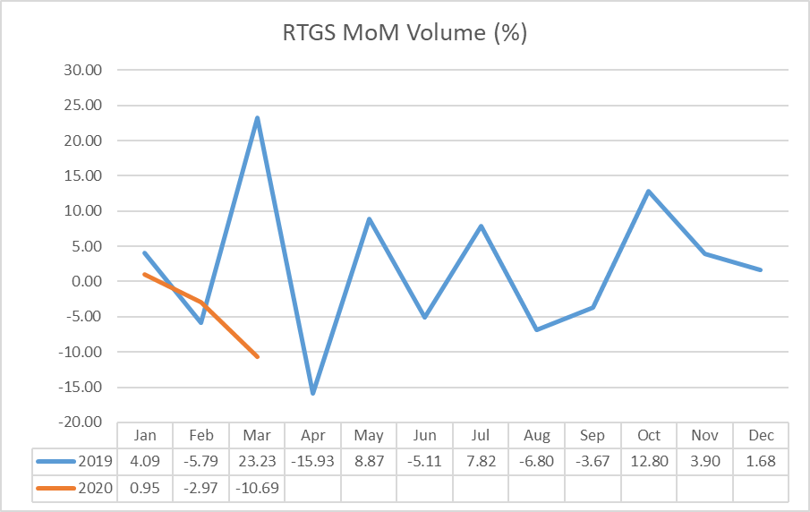

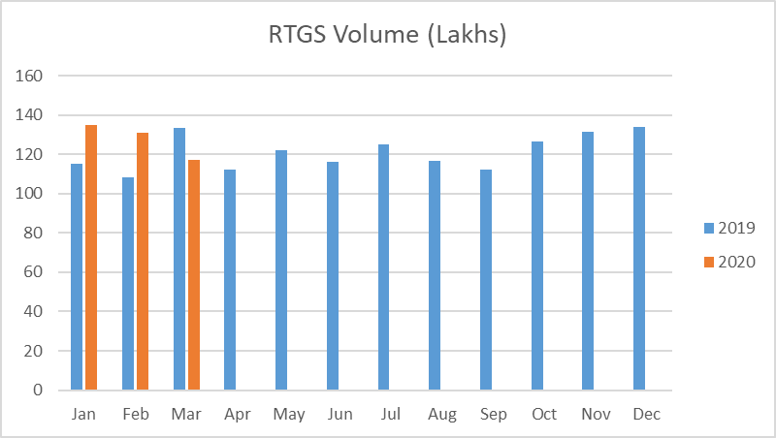

The rate of change in the value of RTGS transactions in March 2020 remained at par with March 2019. The reason for this might be settling of overdue accounts due to the ending of the fiscal year.

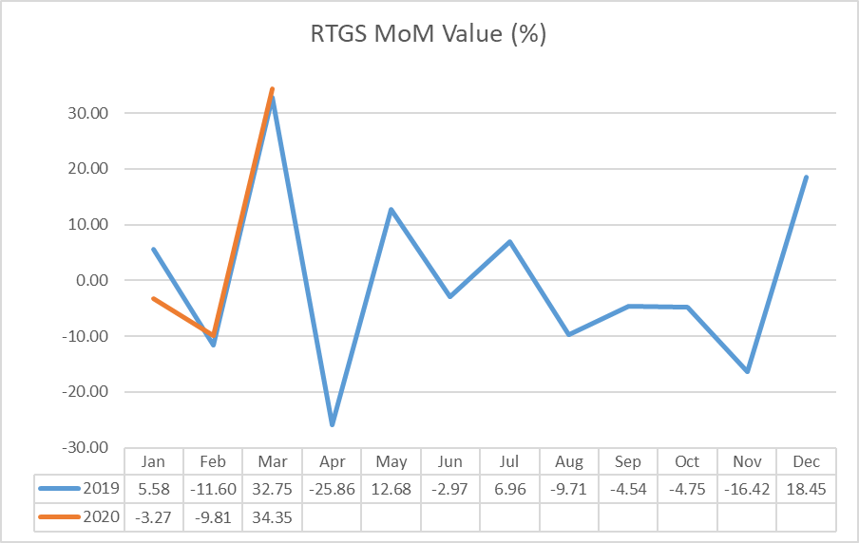

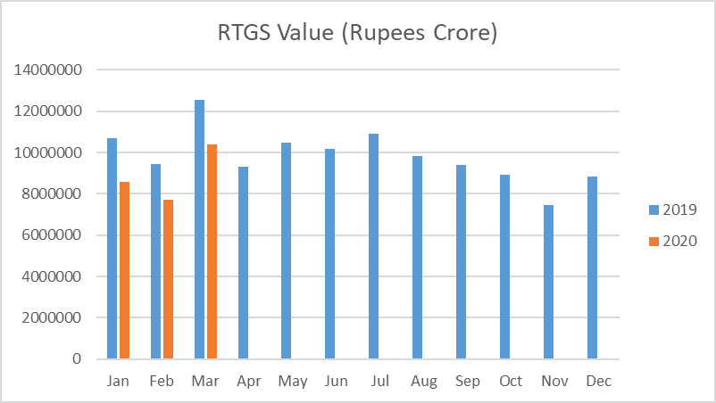

**4.2. NEFT**

There has been a significant difference in the rate of change in the volume of NEFT transactions for the month of March. Since the financial year of India ends in March, usually there is a spike in the volume of transactions in March compared to February as businesses have to close out the financial year accounts. Thus, a high change in the rate of volume of transactions is expected. March 2019 had a change of 20%, however, March 2020 only experienced a change of 5.64% which goes on to show the impact of COVID-19 lockdown. Although the absolute amount of volume of transactions is higher in March 2020, relatively, it is lower than March 2019.

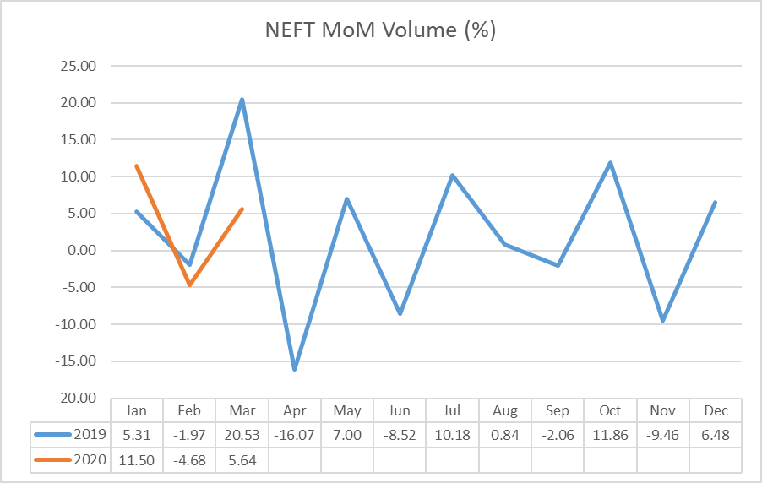

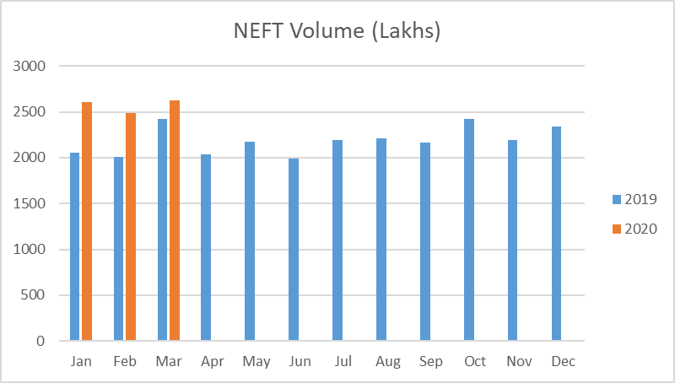

Similarly, there is a one-third difference in the rate of change in the value of NEFT transactions between March 2019 and March 2020 displaying the impact of the lockdown. Unlike the volume of the NEFT transactions, the absolute amount of NEFT transactions in March 2020 is lower than that of March 2019.

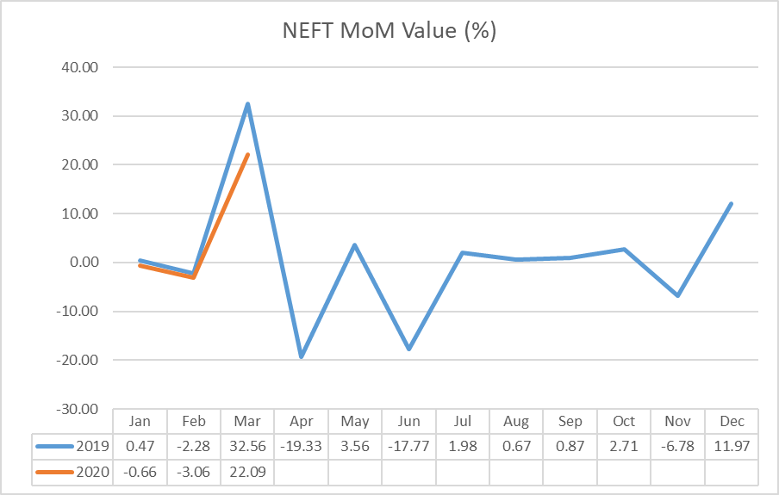

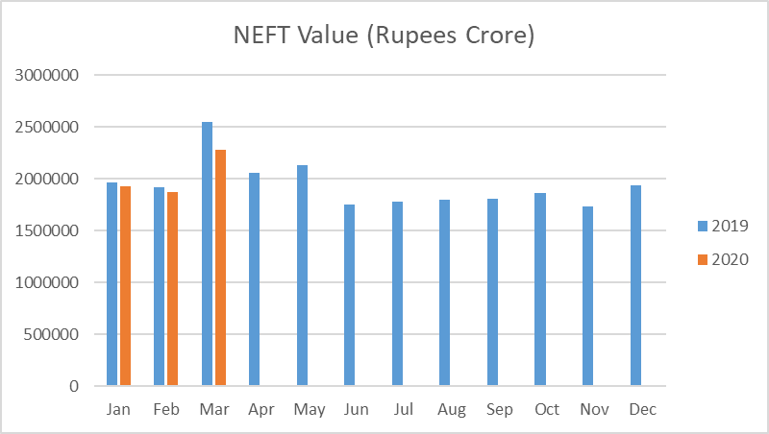

**4.3. IMPS**

The rate of change in the volume of IMPS transactions goes on to show how much COVID-19 has affected the payment systems in India. The considerable difference between the rate of changes of March-April 2019 and March-April 2020 explains the magnitude of the impact of COVID-19. Due to the drastic fall in the volume of IMPS transactions in March 2020 and April 2020, the volume of the transactions is lower in April 2020 than in April 2019.

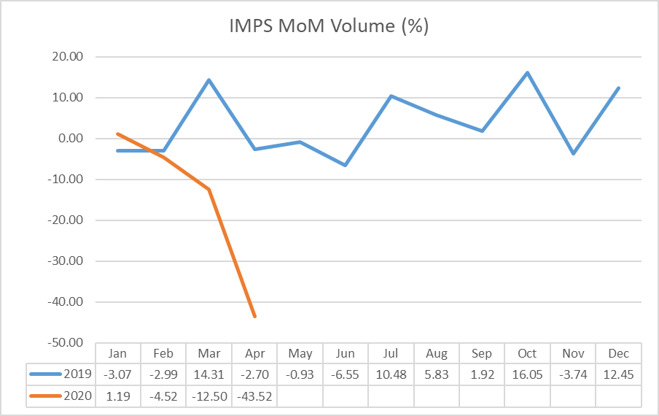

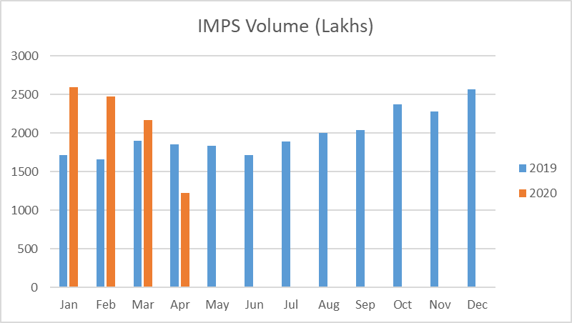

The 40% fall in the value of IMPS transactions for April 2020 compared with a 4% fall for April 2019 has led to the situation where the value of the transactions is lower in April 2020 than in April 2019.

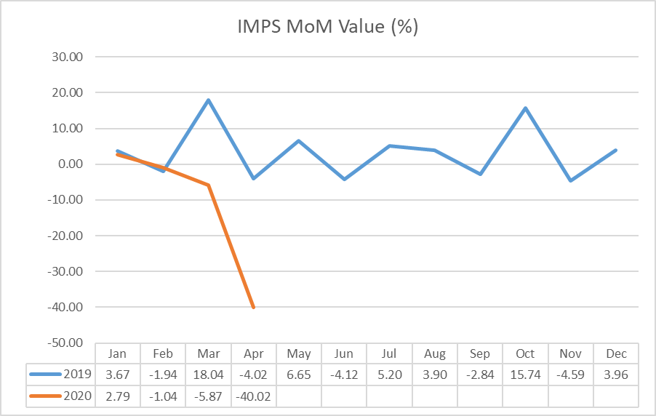

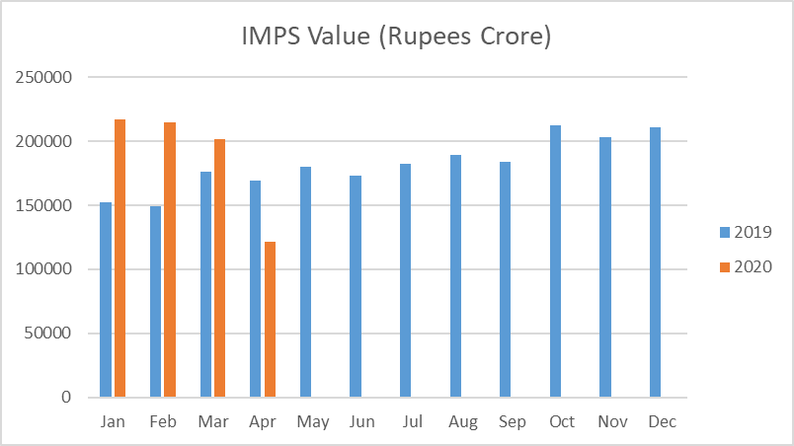

**4.4. UPI**

Although the rate of change in the volume of UPI transactions in February 2020 was similar to that of February 2019, the values for March 2020 and April 2020 are poles apart from the values for March 2019 and April 2019. Although in January 2020 the volume of transactions was nearly the double of what it was in January 2019, the April 2020 figure stands at just 25% more than April 2019.

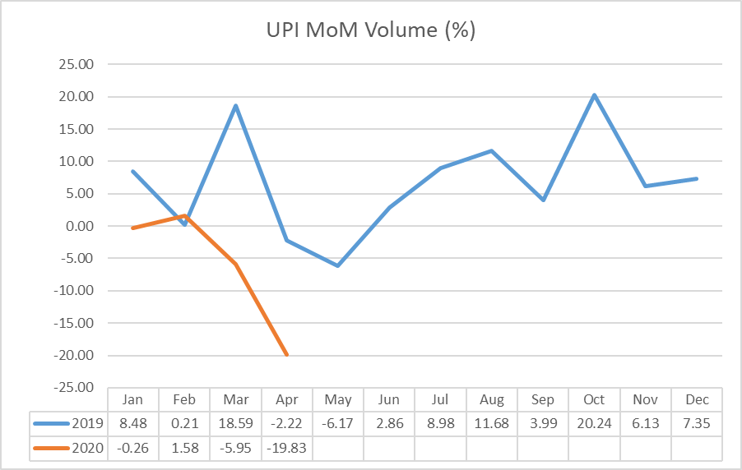

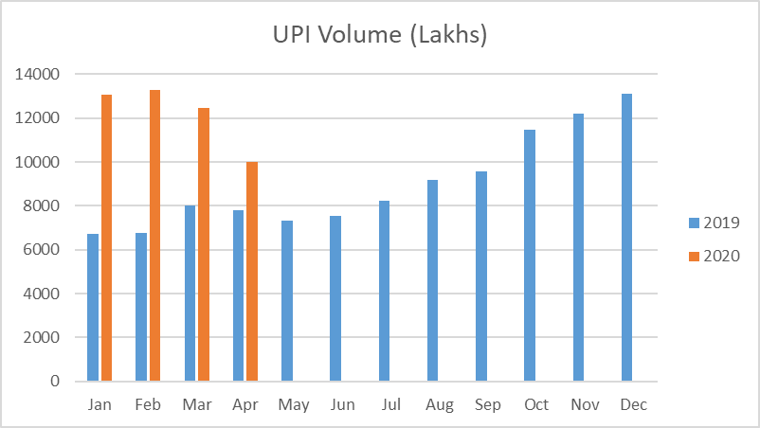

The months of March 2019 and April 2019 had experienced positive change in the value of UPI transactions which led to a total of 33% increase in April 2019 from February 2019. However, both the months of March 2020 and April 2020 had experienced negative change in the value of UPI transactions which led to a total of 32% decrease in April 2019 from February 2019.

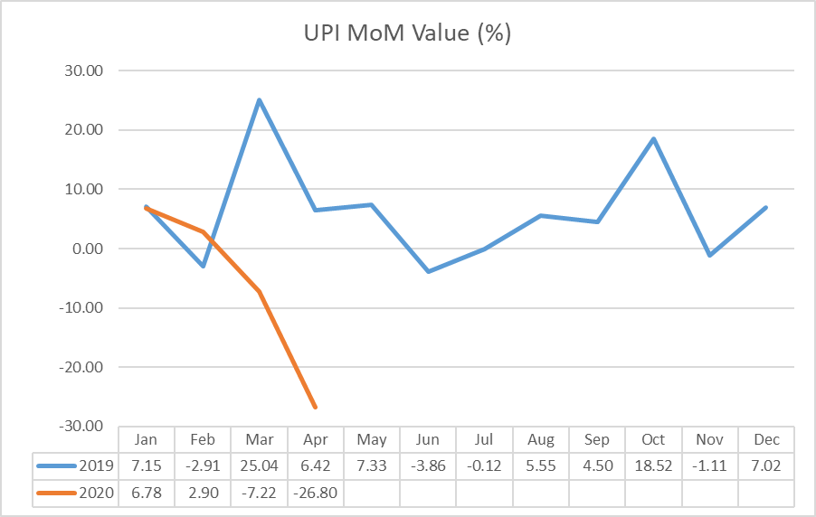

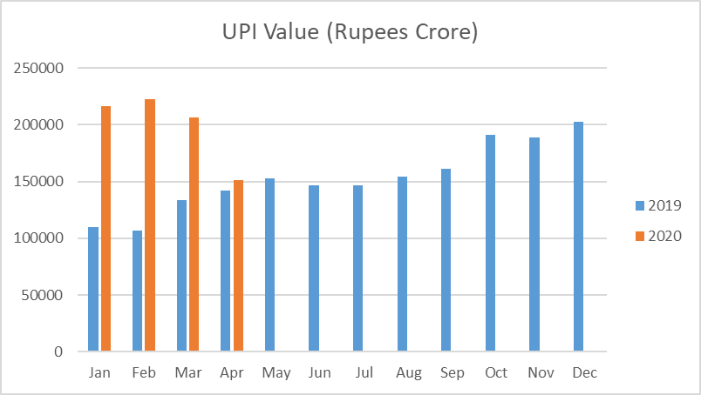

**4.5. Credit Cards**

On one hand there was a 14.91% increase in the volume of Credit card usage at PoS in March 2019, on the other hand there was a 13.1% decrease in the volume of usage in March 2020. The constant decrease in the volume of usage in 2020 has resulted in a situation where the values of March 2020 and March 2019 are almost similar.

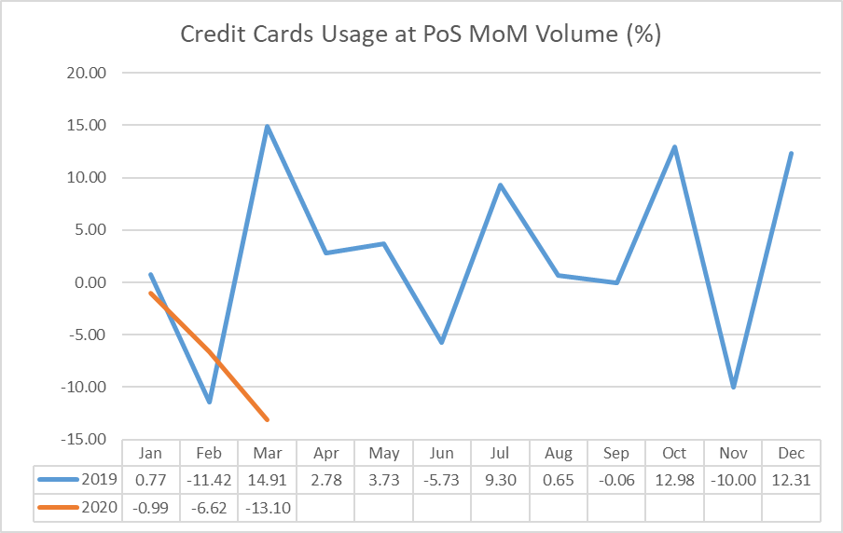

The 18.9% increase in the value of Credit card usage at PoS in March 2019 and the 18.9% decrease in the volume of usage in March 2020 has resulted in the value of usage in March 2020 to be lower than that of March 2019.

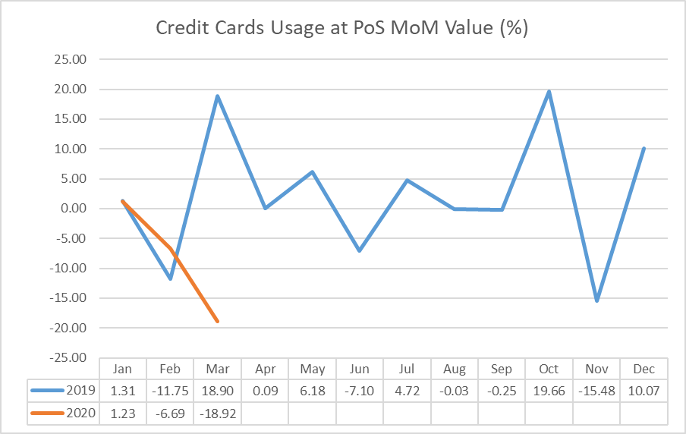

**4.6. Debit Cards**

In the case of Debit Cards, the volume of transactions at both ATMs and POS are affected by COVID. On comparing the MoM rate of change in the volume of transactions at ATMs and POS, one can observe a high positive MoM rate of change in March 2019 (8.99% at ATMs and 17.63% at POS) but a high negative MoM rate of change in March 2020 (12.23% at ATMs and 15.47% at POS).

Volume of transactions at ATMs and POS this year has been higher than the previous year for the first 2 months. That is not the case in the month of March. The value of transactions has been less in March 2020 when compared to March 2019.There is a significant drop in the volume of transactions in March 2020 at ATMs.

A similar trend can be observed in the MOM rate of change of the total value of transactions at both ATMs and POS. A high positive MoM rate of change in March 2019 (11.4% at ATMs and 16.9% at POS) but a high negative MoM rate of change in March 2020 (12.96% at ATMs and 17.63% at POS).

Value of transactions at ATMs and POS this year has been higher than the previous year for the first 2 months. That is not the case in the month of March. The value of transactions has been less in March 2020 when compared to March 2019.

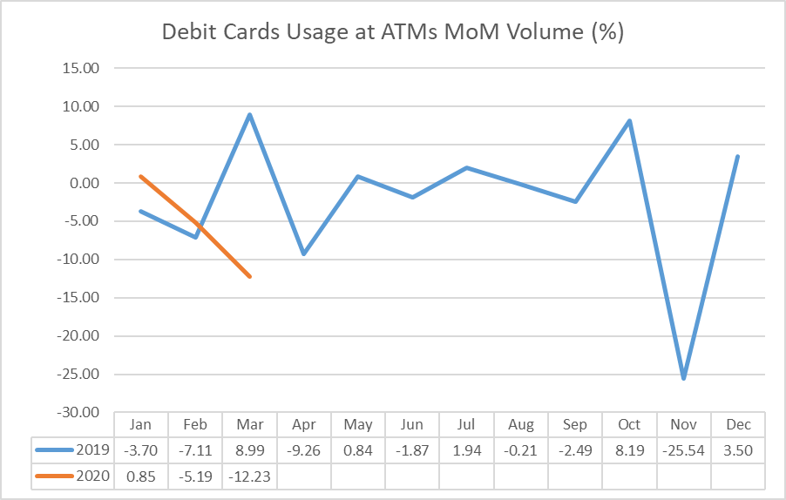

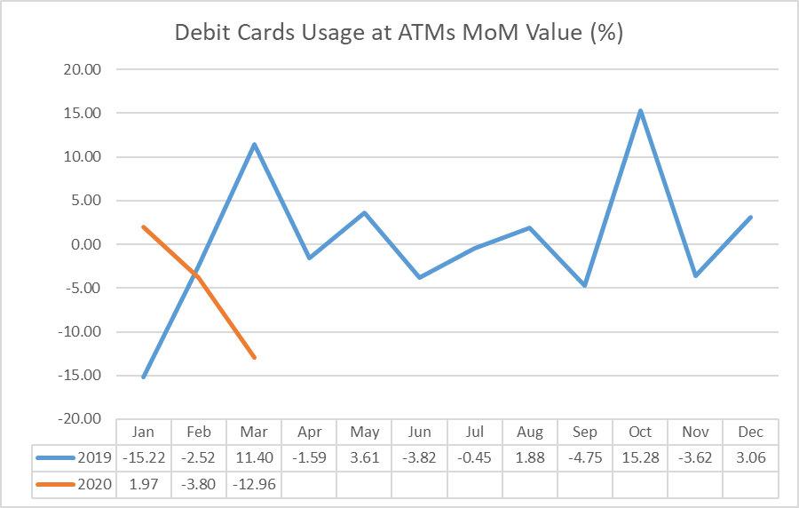

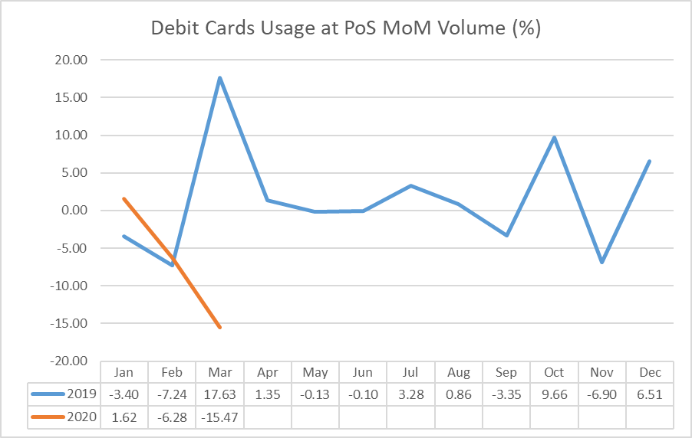

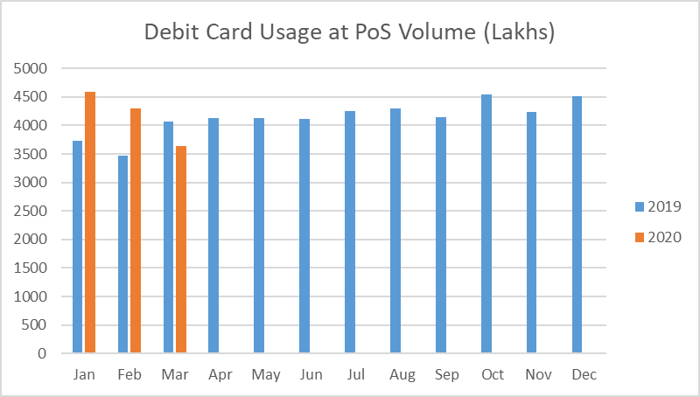

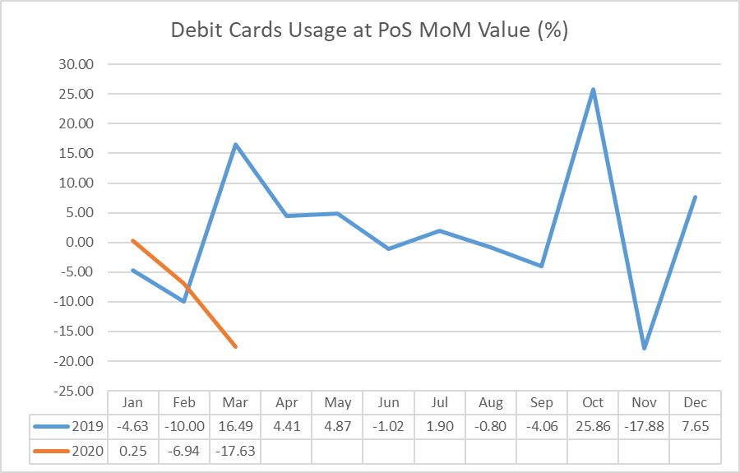

**4.7. Wallets**

On comparing the MoM rate of change in the Volume of Wallets transactions, a clear effect of the COVID-19 lockdown can be observed. Whereas in March 2019, the change in the volume of transactions was high 11.55%, the change in the volume of transactions for March 2020 was a negative 15.97%.

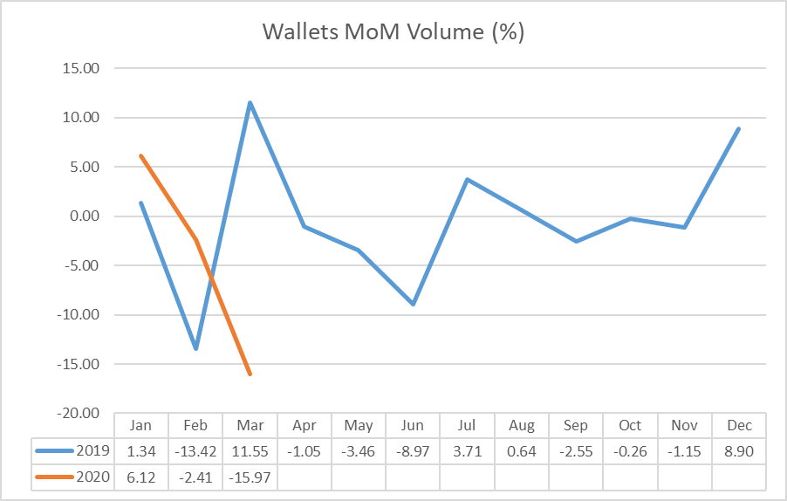

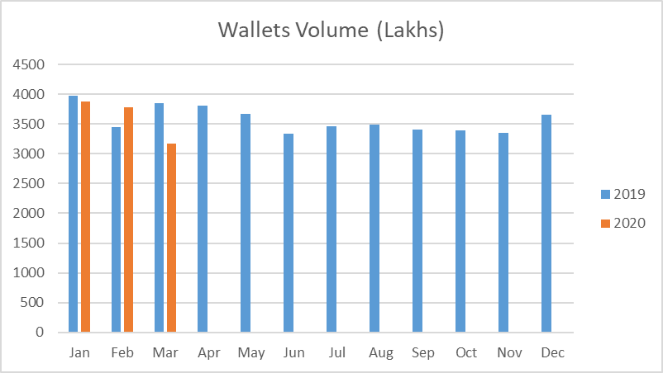

A similar trend can be seen in the MoM rate of change in the value of Wallets transactions as well. For the month of March, 2019 the rate of change was positive at 12.10% but in 2020 due COVID it is negative at 9.33%. A significant drop can be observed in the actual value of wallet transactions from March 2019 to March 2020. The change wasn’t as significant in the first two months of 2020.This reflects that COVID started affecting the transactions in March.

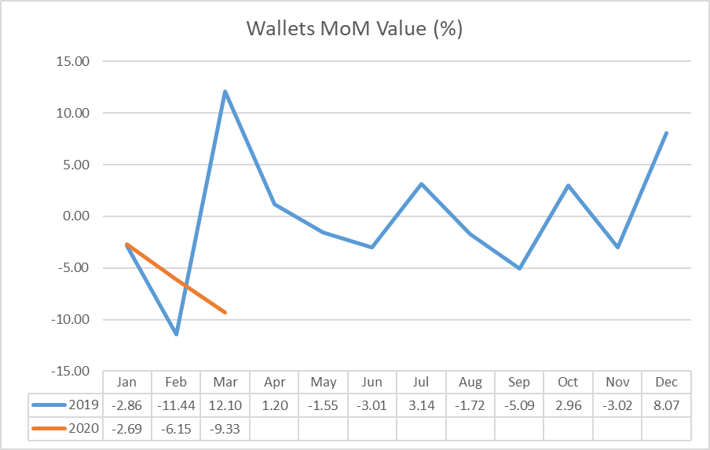

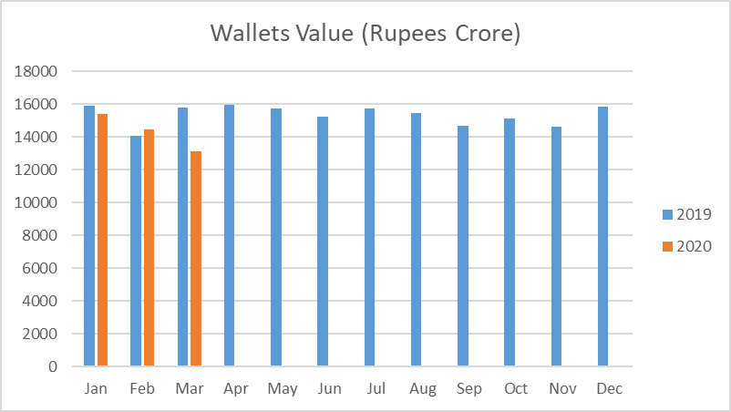

**5. State-wise NPA**

As discussed in the Introduction (Section 1), COVID has negatively impacted our economy. According to a survey by global advisory firm Willis Towers Watson, about 57 percent of organizations in India expect a moderate to large negative impact on their businesses in the next six months while 46 percent expect the effects of COVID-19 pandemic to last over 12 months. This will, in turn, affect the payment of loans in the next 6 to 12 months.

In this section, we study which states would be relatively affected the most in terms of paying the loans, taking into account the factors like the current population of the state as well as the number of confirmed cases in that state.

We have taken 13 states - Maharashtra, Tamil Nadu, Delhi, Gujarat, Rajasthan, Madhya Pradesh, Uttar Pradesh, West Bengal, Andhra Pradesh, Bihar, Kerala, Telangana and Karnataka. These states, as of 4th June 2020, have 90 percent of the total confirmed COVID cases in India and accounted for 87.12% of the total bank credit in the last quarter (2019-20: Q3).

**5.1 State-wise bank credit trend and prediction if there was no COVID**

The following graphs depict the trend for the last 11 quarters (2017-18: Q1 to 2019-20: Q3) as well as the predicted values for the next two quarters if there was no COVID (2019-20: Q4 and 2020-21: Q1).

The bank credit values for the next two quarters were estimated doing a simple time-series analysis on the previous 11 quarters.

**5.1.1 Maharashtra (35.09% of the total confirmed COVID cases in India)**

Maharashtra has the highest number of confirmed COVID cases as well as the highest bank credit in all states.

If there was no COVID, we would have expected a similar trend as last year – the bank credit increases in the last quarter of 2019-20 by 5.35 percent and then slightly decreases in the first quarter of 2020-21 by 0.6 percent.

**5.1.2 Tamil Nadu (12.19% of the total confirmed COVID cases in India)**

Tamil Nadu has the 2nd highest number of confirmed COVID cases and ranks 3rd bank credit wise.

If there was no COVID, we would have expected a similar trend as last year – the bank credit increases in the last quarter of 2019-20 by 2.7 percent and then slightly increases in the first quarter of 2020-21 by 0.9 percent.

**5.1.3 Delhi (10.29% of the total confirmed COVID cases in India)**

Delhi has the 3rd highest number of confirmed COVID cases and ranks 2nd bank credit wise.

If there was no COVID, we would have expected a similar trend as last year – the bank credit increases in the last quarter of 2019-20 by 11.68 percent and then decreases in the first quarter of 2020-21 by 2.9 percent.

**5.1.4 Gujarat (8.71% of the total confirmed COVID cases in India)**

Gujarat has the 4th highest number of confirmed COVID cases and ranks 5th bank credit wise in the country.

If there was no COVID, we would have expected a similar trend as last year – the bank credit increases in the last quarter of 2019-20 by 7.05 percent and then slightly decreases in the first quarter of 2020-21 by 0.75 percent.

**5.1.5 Rajasthan (4.66% of the total confirmed COVID cases in India)**

Rajasthan has the 5th highest number of confirmed COVID cases and ranks 11th bank credit wise in the country.

If there was no COVID, we would have expected a similar trend as last year – the bank credit increases in the last quarter of 2019-20 by 7.6 percent and then again slightly increases in the first quarter of 2020-21 by 0.72 percent.

**5.1.6 Madhya Pradesh (4.2% of the total confirmed COVID cases in India)**

Madhya Pradesh has the 6th highest number of confirmed COVID cases and ranks 13th bank credit wise in the country.

If there was no COVID, we would have expected a similar trend as last year – the bank credit increases in the last quarter of 2019-20 by 2.46 percent and then again increases in the first quarter of 2020-21 by 2 percent.

**5.1.7 Uttar Pradesh (4.19% of the total confirmed COVID cases in India)**

Uttar Pradesh has the 7th highest number of confirmed COVID cases and ranks 7th bank credit wise in the country.

If there was no COVID, we would have expected a similar trend as last year – the bank credit increases in the last quarter of 2019-20 by 5.6 percent and then again slightly increases in the first quarter of 2020-21 by 0.55 percent.

**5.1.8 West Bengal (2.85% of the total confirmed COVID cases in India)**

West Bengal has the 8th highest number of confirmed COVID cases and ranks 8th bank credit wise in the country.

If there was no COVID, we would have expected a similar trend as last year – the bank credit increases in the last quarter of 2019-20 by 2.36 percent and then slightly decreases in the first quarter of 2020-21 by 0.97 percent.

**5.1.9 Bihar (2% of the total confirmed COVID cases in India)**

Bihar has the 9th highest number of confirmed COVID cases and ranks 16th bank credit wise in the country.

If there was no COVID, we would have expected a similar trend as last year – the bank credit increases in the last quarter of 2019-20 by 4.52 percent and then again increases in the first quarter of 2020-21 by 2.3 percent.

**5.1.10 Andhra Pradesh (1.91% of the total confirmed COVID cases in India)**

Andhra Pradesh has the 10th highest number of confirmed COVID cases and ranks 9th bank credit wise in the country.

If there was no COVID, we would have expected a similar trend as last year – the bank credit increases in the last quarter of 2019-20 by 7.34 percent and then again slightly increases in the first quarter of 2020-21 by 0.47 percent.

**5.1.11 Karnataka (1.77% of the total confirmed COVID cases in India)**

Karnataka has the 11th highest number of confirmed COVID cases and ranks 4th bank credit wise in the country.

If there was no COVID, we would have expected a similar trend as last year – the bank credit increases in the last quarter of 2019-20 by 3.63 percent and then again increases in the first quarter of 2020-21 by 1.04 percent.

**5.1.12 Telangana (1.54% of the total confirmed COVID cases in India)**

Telangana has the 13th highest number of confirmed COVID cases and ranks 6th bank credit wise in the country.

If there was no COVID, we would have expected a similar trend as last year – the bank credit increases in the last quarter of 2019-20 by 3 percent and then slightly decreases in the first quarter of 2020-21 by 0.5 percent.

**5.1.13 Kerala (0.7% of the total confirmed COVID cases in India)**

Kerala has the 18th highest number of confirmed COVID cases and ranks 10th bank credit wise in the country.

If there was no COVID, we would have expected a similar trend as last year – the bank credit increases in the last quarter of 2019-20 by 4.19 percent and then again slightly increases in the first quarter of 2020-21 by 0.38 percent.

**5.2 Factors taken into account to study the relative impact of COVID on non-payment of bank credit**

The two factors that we have taken into account to study the relative impact of COVID on non-payment of bank credit is the total number of confirmed COVID cases and the population in each of the 13 states.

Using the total number of confirmed COVID cases in each state, we found the percentage of cases in each of the 13 states that contributes to the total number of confirmed cases. Using the following formula,

$$\%COVID cases in the state= \frac{Number of confirmed cases in the state}{Total number of confirmed cases in the 13 states} ×100$$

Then we found out the percentage of COVID affected population in each state.

$$\% COVID affected population of the state= \frac{Number of confirmed cases in the state}{Total population of that state} ×100$$

Finally, to study the relative impact we added the % COVID affected population of the 13 states and calculated the percentage contribution of each state in it.

Table 1

|  |  |  |  |  |  |
| --- | --- | --- | --- | --- | --- |
| State | Confirmed COVID cases | Population | %COVID cases in the state (A) | % COVID affected population | % Contribution of the state to the total % COVID affected population (B) |
| MAHARASHTRA | 67655 | 123144223 | 38.95% | 0.0549 | 20.11% |
| TAMIL NADU | 23495 | 77841267 | 13.53% | 0.0302 | 11.05% |
| DELHI | 19844 | 18710922 | 11.43% | 0.1061 | 38.82% |
| GUJARAT | 16794 | 63872399 | 9.67% | 0.0263 | 9.63% |
| RAJASTHAN | 8980 | 81032689 | 5.17% | 0.0111 | 4.06% |
| MADHYA PRADESH | 8089 | 85358965 | 4.66% | 0.0095 | 3.47% |
| UTTAR PRADESH | 8075 | 237882725 | 4.65% | 0.0034 | 1.24% |
| WEST BENGAL | 5501 | 99609303 | 3.17% | 0.0055 | 2.02% |
| ANDHRA PRADESH | 3676 | 53903393 | 2.12% | 0.0068 | 2.50% |
| BIHAR | 3872 | 124799926 | 2.23% | 0.0031 | 1.14% |
| KERALA | 1327 | 35699443 | 0.76% | 0.0037 | 1.36% |
| TELANGANA | 2968 | 39362732 | 1.71% | 0.0075 | 2.76% |
| KARNATAKA | 3408 | 67562686 | 1.96% | 0.0050 | 1.85% |
| **TOTAL** | **173684** | **1108780673** | **100.00%** | **0.2732** | **100.00%** |

Using the percentage of affected COVID population in the state as a means to measure the percentage of unpaid bank credit, we may conclude that column (B) of Table 1 would reflect the relative impact of COVID on the amount of unpaid bank credit in the respective states after August 2020. So more the value under column (B) of Table 1, more would be the relative impact on the amount of unpaid bank credit in that particular state.

For example in the case of Delhi, 0.1% of the total population is affected by COVID with 19844 confirmed cases and it contributes to about 11.43% of the total confirmed cases amongst the 13 states. It contributes to about 38.82% to the total % COVID affected population, which is the highest amongst the 13 states. Therefore, we can conclude that Delhi will be the most affected state in terms unpaid bank credit due to COVID.

Hence, even though Maharashtra has the highest number of confirmed COVID cases in the country, payment of bank credit will be not as affected as Delhi. This can be explained by Delhi’s higher percentage of COVID affected population of 0.1 percent compared to Maharashtra’s 0. 05 percent.

Table 2 provides the expected unpaid bank credit due to COVID post August 2020.

Table 2